**Replication Master to Slave**

**High Availability and Scalability**

Replication enables data from one MySQL database server (the master) to be replicated to one or more MySQL database servers (the slaves). Replication is asynchronous - slaves need not be connected permanently to receive updates from the master. Depending on the configuration, you can replicate all databases, selected databases, or even selected tables within a database.

**Advantages:**

1.It makes backing up the database easier and safer.

2.Gives more performance with load balancing. we can split the load between two servers by directing reads to the slave server and writes to the master server.

3.We can replicate from one storage engine to another storage engine.

4.We can use this slave server for data analysis, reports etc....instead on impacting the production server we can do this in slave server and even we can shutdown the slave server.

**Disadvantages:**

1.The main disadvantage of replication is there is no guaranty of data synchronization between two servers.

2.**No automatic fail over technique in case if master fails**. This causes a little down time.

3.User defined variables and temporary tables may not work.

4.If replication is set with multiple slaves it may cause some load on master server to updated the statement to all the slaves.

**Replication Formats:**

Replication is of three formats:

1. STATEMENT BASED

2. ROW BASED

3. MIXED-FORMAT (Combination of statement based and row based)

**Statement Based:** All statements propagates from master to slave and executes the statements on slave.

**Advantages of Statement-Based Replication:**

1. Less data written to log files. This results less storage space for log files.

2. Log files contains all the changes made to the database. so they can be used to track the database changes.

**Disadvantages of Statement-Based Replication:**

1. Queries using function like NOW(), RAND(), CURDATE(), UUID() etc are unsafe.

2. DELETE and UPDATE queries using a LIMIT clause and without using ORDER BY clause are unsafe.

3. Queries requires more number of locks on tables.

**Row Based:** Row-based binary logging logs changes in individual table rows.

**Advantages of Row-Based Replication:**

1. All queries can be replicated safely.

2. Queries requires less number of locks on tables.

**Disadvantages of Row-Based Replication:**

1. Large data written to log files. This results large storage space for log files.

This would take a little longer time when statements like BLOB and TEXT values are encountered.

2. We cannot track the logs to find the changes committed to the database.

**Mixed Based:** When the mixed format is in effect, statement-based logging is used by default,

but automatically switches to row-based logging

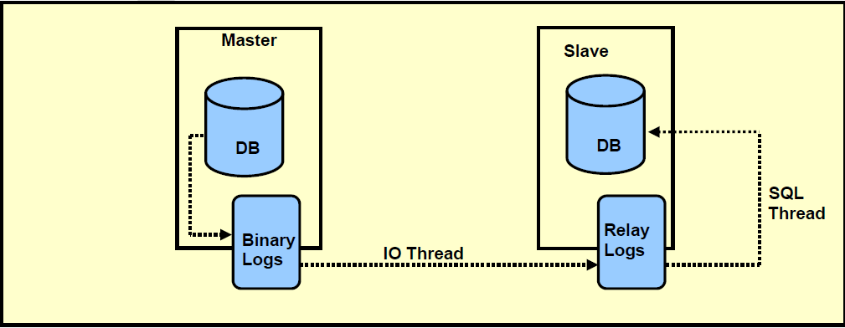

**Master Server : 192.168.227.131**

**Slave Server 1 : 192.168.227.132**

**Slave Server 2 : 192.168.227.133**

Take Backup and restore steps .. need to update ..

---Enable below parameters in my.cnf file

server-id = 1

log_bin = /var/log/mysql/mysql-bin.log

expire_logs_days = 10

max_binlog_size = 100M

#binlog_do_db = test

bind-address = 0.0.0.0

#sudo service mysql restart

GRANT REPLICATION SLAVE ON *.* TO 'repluser'@'192.168.227.132' **[slave ipaddress ]**

IDENTIFIED BY 'repl123';

FLUSH PRIVILEGES;

mysql> show master status;

+------------------+----------+--------------+------------------+

| File | Position | Binlog_Do_DB | Binlog_Ignore_DB |

+------------------+----------+--------------+------------------+

| mysql-bin.000001 | 956 | | |

+------------------+----------+--------------+------------------+

1 row in set (0.04 sec)

**Slave Server 1 : 192.168.227.132**

Enable in my.cnf file the below

server_id=2

bind-address = 0.0.0.0

#sudo restart mysql server

CHANGE MASTER TO MASTER_HOST='192.168.227.131',MASTER_USER='repluser', MASTER_PASSWORD='repl123', MASTER_LOG_FILE= 'mysql-bin.000001', MASTER_LOG_POS= 956;

START SLAVE;

SHOW SLAVE STATUS\G

Check the below values from above command result set

Slave_IO_Running: Yes

Slave_SQL_Running: Yes

Seconds_Behind_Master: 0

**Slave 2 server:** 192.168.227.133

enable in my.cnf file the below

server_id=3

#sudo restart mysql server

CHANGE MASTER TO MASTER_HOST='192.168.227.133',MASTER_USER='repluser', MASTER_PASSWORD='repl123', MASTER_LOG_FILE= 'mysql-bin.000001', MASTER_LOG_POS= 956;

Slave Server – For Reporting Purpose you can set in read only mode

**MySQL:**

**To Set a database to read-only mode in Mysql:**

FLUSH TABLES WITH READ LOCK;

SET GLOBAL read_only = 1;

To Set the database back to **Read+Write** mode:

SET GLOBAL read_only = 0;

UNLOCK TABLES;

SET GLOBAL SQL_SLAVE_SKIP_COUNTER=1;

START SLAVE;